You are given the head of a linked list, and an integer k.

Return *the head of the linked list after****swapping****the values of the*kth *node from the beginning and the*kth *node from the end (the list is****1-indexed****).*

**Example 1:**

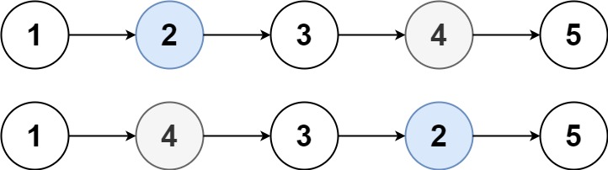

**Input:** head = [1,2,3,4,5], k = 2

**Output:** [1,4,3,2,5]

**Example 2:**

**Input:** head = [7,9,6,6,7,8,3,0,9,5], k = 5

**Output:** [7,9,6,6,8,7,3,0,9,5]

**Example 3:**

**Input:** head = [1], k = 1

**Output:** [1]

**Example 4:**

**Input:** head = [1,2], k = 1

**Output:** [2,1]

**Example 5:**

**Input:** head = [1,2,3], k = 2

**Output:** [1,2,3]

**Constraints:**

* The number of nodes in the list is n.
* 1 <= k <= n <= 105
* 0 <= Node.val <= 100